Q1IM to ServiceNow Configuration:
1) Created process triggered by Events (INSERT, UPDATE, etc...)...BaseObject is custom table created named "TQA_ServiceNow"
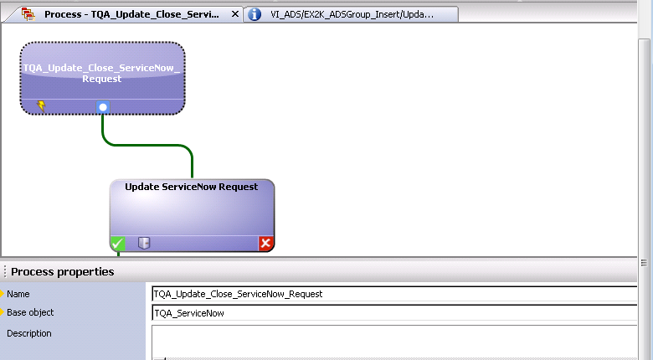
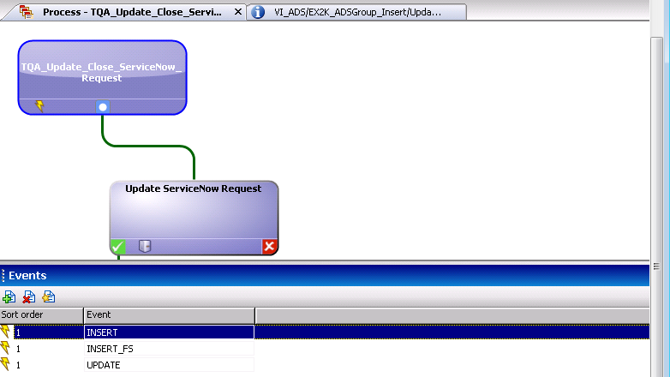
2) Created Process Step to call script that updates PwO table with any INSERT that comes from ServiceNow to table "TQA_ServiceNow" (acknowledge). ServerMask set to Master SQL Server.
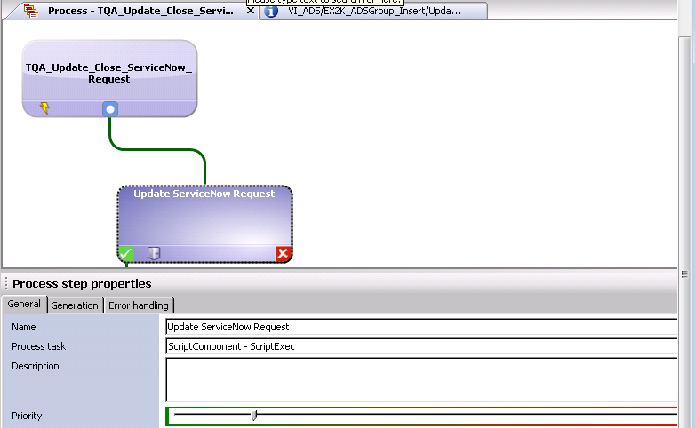
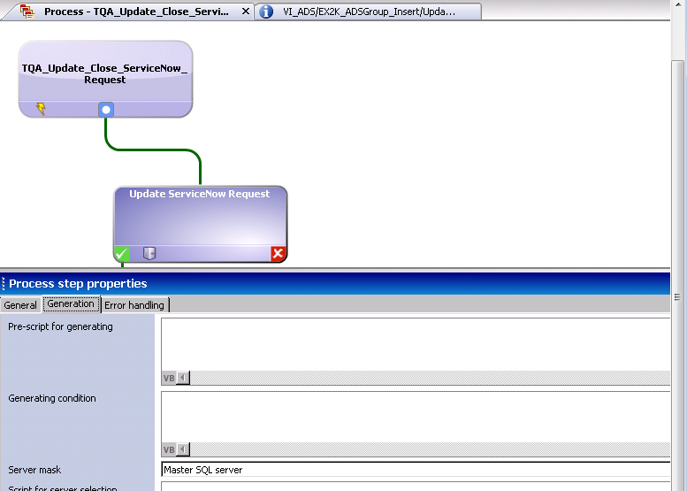
3) Parameters set to call script and pass values from ServiceNow acknowledge (INSERT), boolean result TRUE returned to proceed to next step
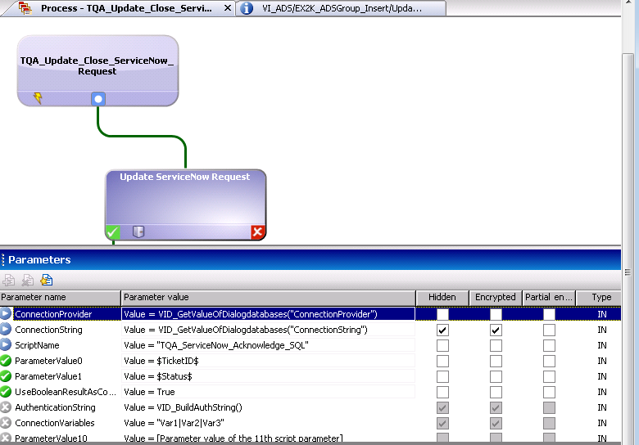
4) Next step is check if Ticket is Closed (INSERT to 'ClosedBy' column)...
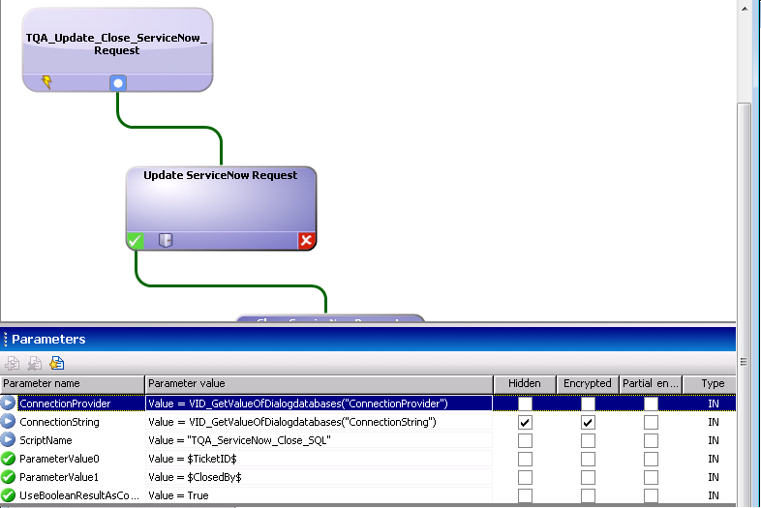
5) Screenshot of custom table "TQA_ServiceNow" with values populated by Acknowledge/Close
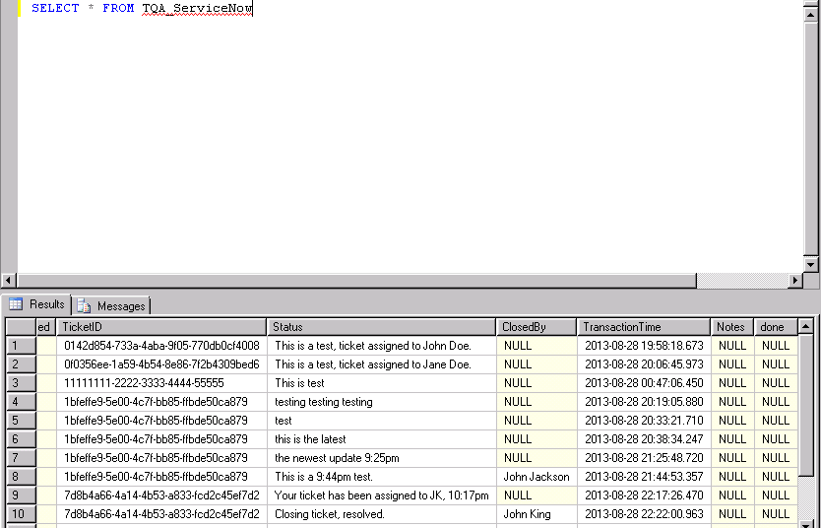
6) Acknowledge Test
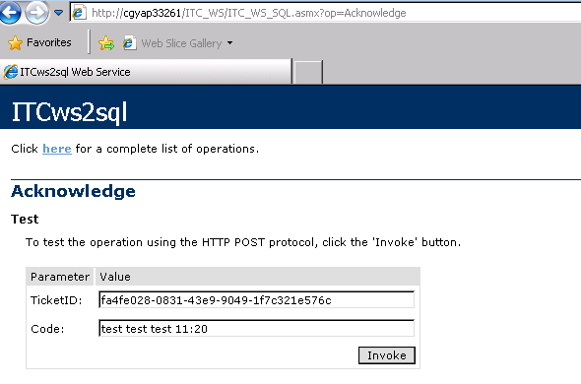

7) Close Test
